1 Open 

2 Run the file 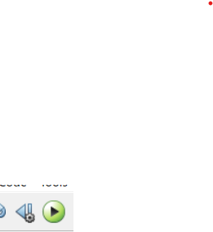

3 robot will appear 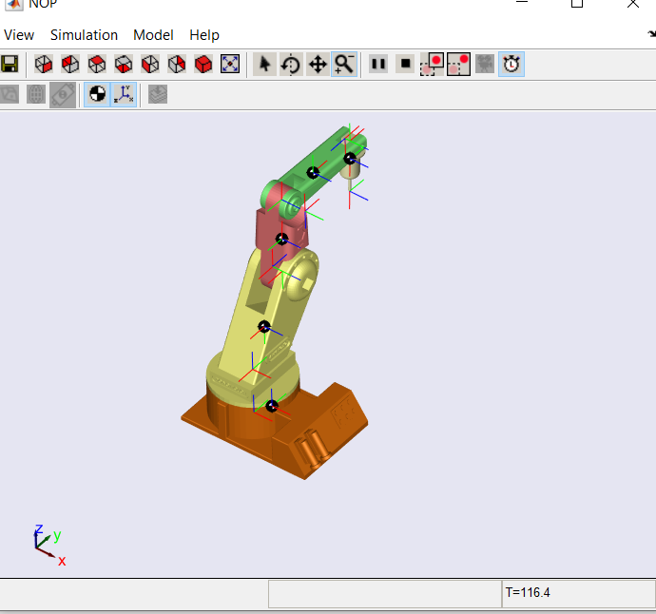

4 now open the program and press play

Applet will appear with slider

Note

Tel1.m fife has only single slider